**Practice Worksheet**

The advance of the sea

Below is a graph of a prediction of the advance of the sea in a coastal area of the Valparaíso region.

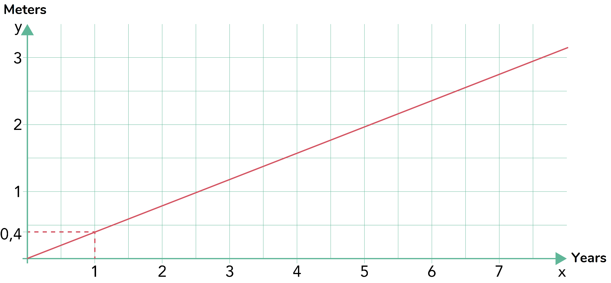

Questions:

1. What type of proportionality does it correspond to? Justify.

1. How much would the sea advance in this area after 9 years?
2. What is the algebraic expression or formula that models this situation?
3. Complete the following table using the formula found:

| *X*  Time (years) | 1 | 5 | 12 | 16 | 20 |
| --- | --- | --- | --- | --- | --- |
| *Y*  Advance of the sea (meters) |  |  |  |  |  |
| Quotient *Y : X* |  |  |  |  |  |

1. In 2023, a house is located 30 meters from the sea on the coast of Valparaíso. In how many more years will the sea have reached the house? What year will it be?

**Solutions**

| **Act. 1** |  | It is a direct proportionality, since it is a line that passes through the point (0,0). |
| --- | --- | --- |
| **Act. 2** |  | Since each year the sea advances 0,4 meters, then, after 9 years the sea would advance 3,6 meters. |
| **Act. 3** |  | $y = 0,4⋅x$ |
| **Act. 4** |  | | *X*  Time (years) | 1 | 5 | 12 | 16 | 20 | | --- | --- | --- | --- | --- | --- | | *Y*  Advance of the sea (meters) | 0,4 | 2 | 4,8 | 6,4 | 8 | | Quotient *Y : X* | 0,4 | 0,4 | 0,4 | 0,4 | 0,4 | |
| **Act. 5** |  | $30 = 0,4⋅x$ $x = \frac{30}{0,4}$ $x =75$ Answer: In 75 more years, that is, the year 2098, the sea will have reached the house. |