**Activity Worksheet**

The advance of the sea

| Different predictions have been made about the speed at which the sea will advance in some locations of the Chilean coast. Below are two of them:   * In Antofagasta, the sea's advance rate will be 6 meters every 10 years. * In Constitución, the sea's advance rate will be 8 meters every 10 years. |
| --- |

Use the information provided to complete the following activities.

1. Draw the graphs of the predictions of the advance of the sea for each of the coastal areas mentioned.

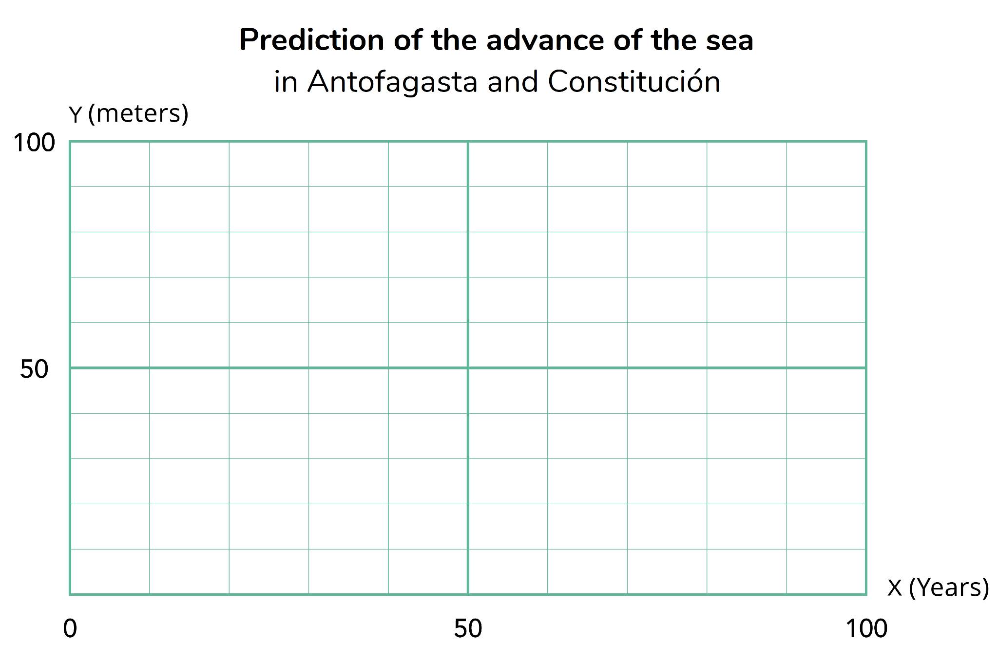

1. In which coastal area is the sea advancing the fastest? How does it relate to the graph?
2. How many meters will the sea have advanced in Antofagasta and Constitución in 50 more years?
3. How many meters will the sea have advanced in Antofagasta and Constitución in 30 more years?
4. Write a formula that describes the relationship between time and the advance of the sea for the coastal areas of Antofagasta and Constitución.
5. Use the formulas to calculate the advance of the sea after 2 years.
6. In 2023, houses were built a few meters from the beach in the coastal area of Antofagasta and Constitución.

* In Antofagasta, the house is 15 meters from the coast.
* In Constitución, the house is 20 meters from the coast.

1. In each case, write on the signs the year the sea will advance the indicated meters.

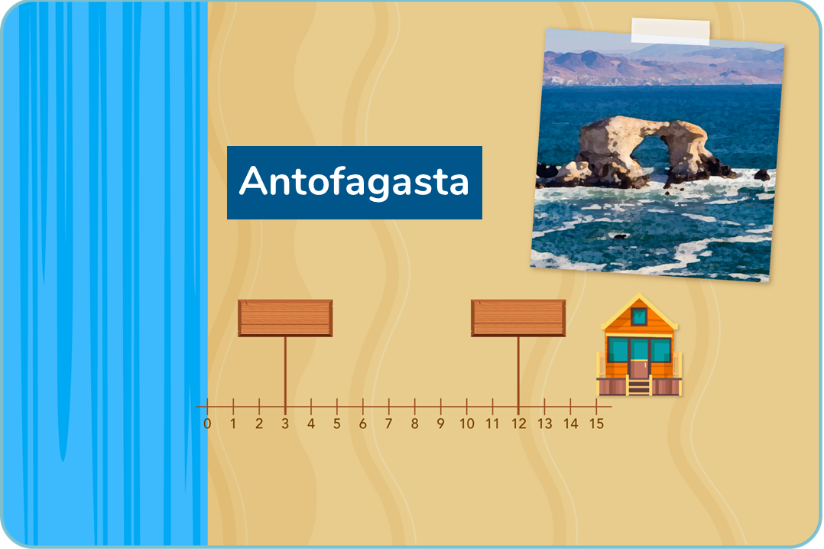

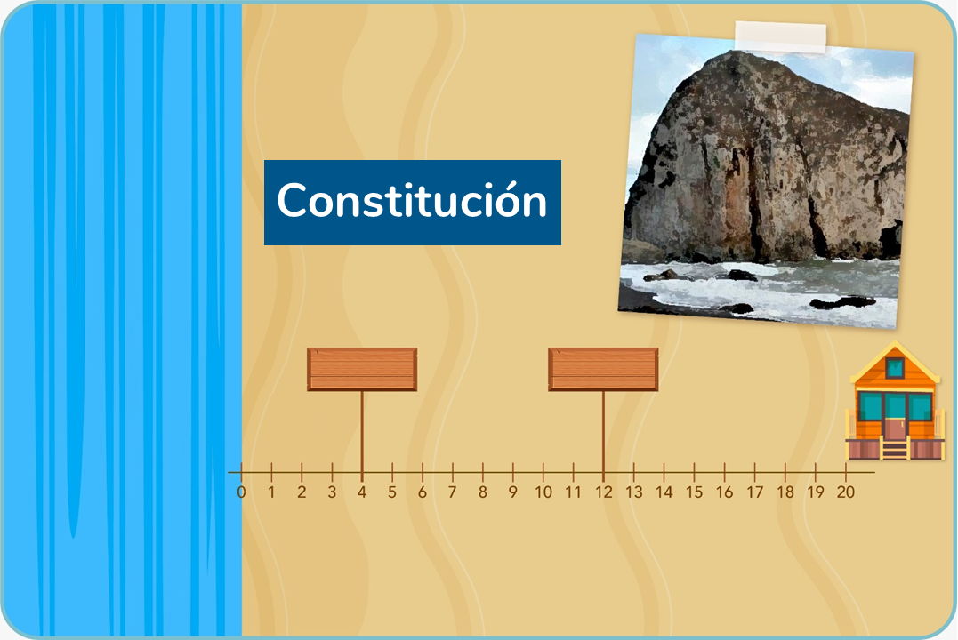

1. Which house will the sea reach first? In what year?