Practice Worksheet
Where to locate a solar plant in Chile?

We answered the following question:

Where will it be more convenient to install a solar power plant that supplies electricity to the city of Concepción: in Atacama or in Concepción?

For this, the following information was available:

 | Plant in Atacama | Plant in Concepción | 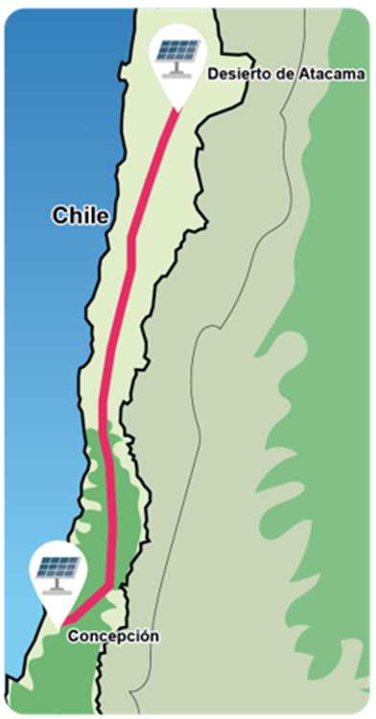
Power if the Sun per m² on the external surface of the atmosphere | 1,4 kW | 1,4 kW
Percentage of light that is absorbed by humidity before reaching the solar panel | 54% | 61%
Hours of sunshine per day* | 12 | 12
Sunny days per year* | 349 | 296
Percentage of light that is lost in the panel in heat and other effects | 80% | 80%
Percentage of energy lost in transmission cables | 9% | 0%

*Days and hours with sunlight conditions that allow the photovoltaic panels to operate. These are average values.
__________________________________________________________________________

Work as a group to answer the following questions. Use the GeoGebra app found at the following link: https://www.geogebra.org/m/zj55zdez. Move the sliders until you obtain the variables' values in each case.

- Use the GeoGebra app to check the results you obtained when calculating the amount of energy supplied to Concepción by each plant, considering the data in the previous table.

- In 5 years, the technology of photovoltaic panels will probably be improved, reducing the percentage of light lost in heat and other effects to 75%. In this scenario, what is the amount of energy that each plant can deliver to Concepción?

- In the same previous scenario, an improvement in energy transmission is also expected, which would imply only a 5% loss in the cables for the plant in Atacama. In this scenario, what is the amount of energy that said plant can deliver to Concepción?

- Use the GeoGebra app to evaluate where it is more convenient to install the plant if this time it is required to provide energy to Valdivia, and we have the following data

 | Plant in Atacama | Plant in Valdivia
Power if the Sun per m² on the external surface of the atmosphere | 1,4 kW | 1,4 kW
Percentage of light that is absorbed by humidity before reaching the solar panel | 54% | 65%
Hours of sunshine per day* | 12 | 12
Sunny days per year* | 349 | 271
Percentage of light that is lost in the panel in heat and other effects | 80% | 80%
Percentage of energy lost in transmission cables | 12% | 0%

Solutions

1 | Plant in Atacama:  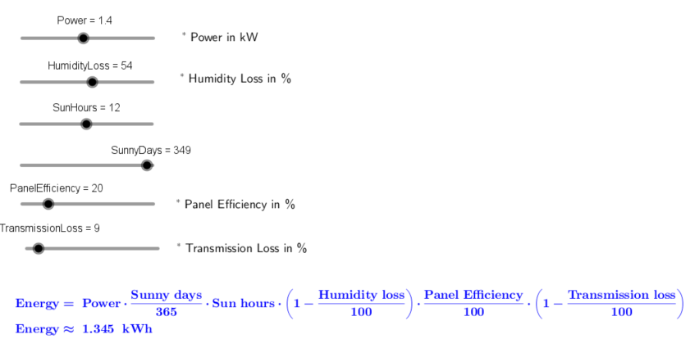  Plant in Concepción:  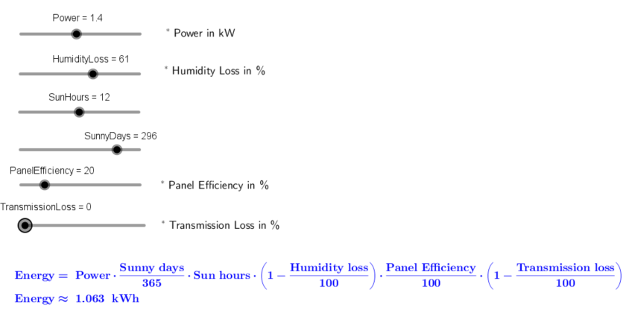
2 | Plant in Atacama:  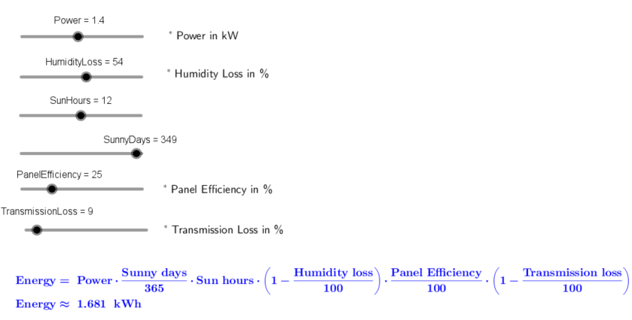  Plant in Concepción:  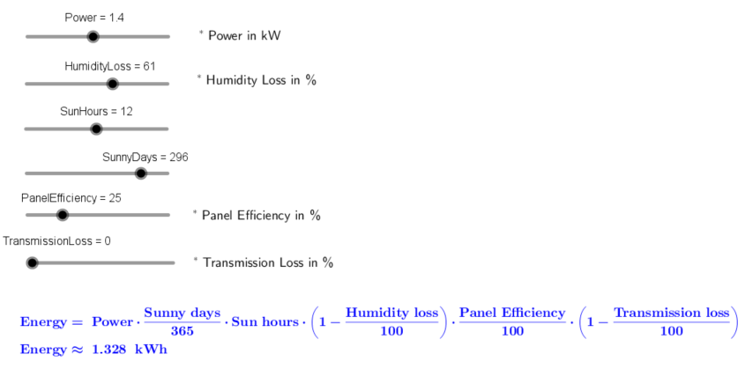
3. | 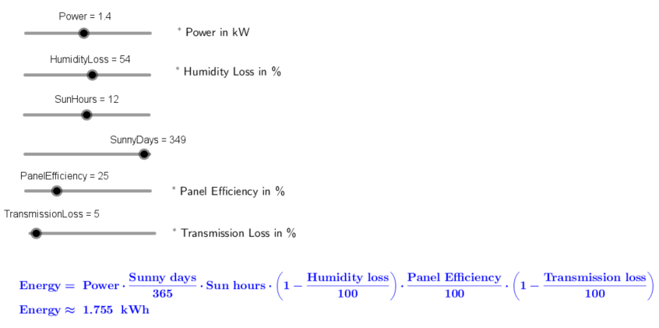
4. | Plant in Atacama:  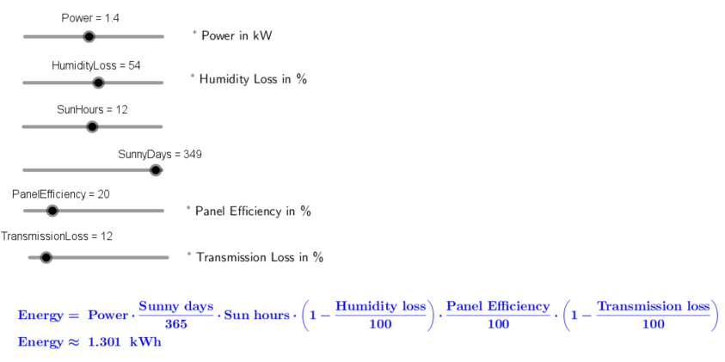  Plant in Valdivia:  